Three Parishes One Faith – Faith Formation Schedule
5K – 6th Grades at Holy Rosary
Wednesday Program September through December 2025
Date | Class Time | Details
September 10th | 6:00 – 7:00 P.M.
September 17th | 6:00 – 7:00 P.M.
September 24th | FF opening Mass at SSPP. 6:00 PM All students’ 5K – 10th and families | Meeting following Mass, NOT MANDATORY. Please email agenda items to drethreeparishes@gmail.com
October 1st | 6:00 – 7:00 P.M.
October 8th | 6:00 – 7:00 P.M..
October 15th | 6:00 – 7:00 P.M.
October 22nd | 6:00 – 7:00 P.M..
October 29th | 6:00 – 7:00 P.M.
November 5th | 6:00 – 7:00 P.M.
November 12th | 6:00 – 7:00 P.M.
November 19th | 6:00 – 7:15 P.M.. | Family Event  Parents of students in 5K – 6th grades should attend with their children for an Advent project. Please gather in Spartan Hall
November 26th | NO CLASS. | Happy Thanksgiving
December 3rd | 6:00 – 7:00 P.M.
December 10th | 6:00 – 7:00 P.M.

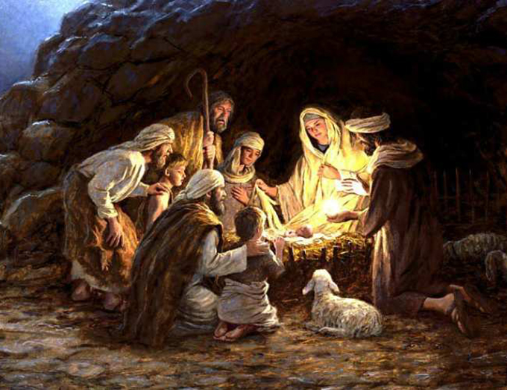

Merry Christmas and Happy New Year!!!
Please see the other side of this page for the 2nd semester schedule.
Three Parishes One Faith – Faith Formation Schedule
5K – 6th Grade at Holy Rosary
Wednesday Program January through May 2026
Date | Class Time | Details
January 7th | 6:00 – 7:00 P.M.
January 14th | 6:00 – 7:00 P.M.
January 21st | 6:00 – 7:00 P.M.
January 28th | 6:00 – 7:00 P.M.
February 1st | 6:00 – 7:00 P.M.
February 4th | 6:00 – 7:00 P.M.
February 11th | 6:00 – 7:15 P.M. | Family Event  Parents of students in 5K – 6th grades should attend with their children for a Lent project. Please gather in Spartan Hall.
February 18th | NO CLASS | ASH WEDNESDAY MASS - SEE BULLETIN for Mass times.
February 25th | 6:00 – 7:00 P.M.
March 4th | 6:00 – 7:00 P.M.
March 11th | 6:00 – 7:00 P.M.
March 18th | 6:00 – 7:00 P.M.
March 25th | 6:00 – 7:00 P.M.
April 1st | NO CLASS | HOLY WEEK - SEE BULLETIN FOR MASS TIMES.
April 8th | 6:00 – 7:00 P.M.
April 15th | 6:00 – 7:00 P.M.
April 22nd | 6:00 – 7:00 P.M.
April 29th | 6:00 – 7:00 P.M.
May 6th | 6:00  FF Closing Mass | 6:00 Mass All students /families’ 5K – 10th.  At Holy Rosary

