Three Parishes One Faith – Faith Formation Schedule
5K – 8th Grades at St. Ann
Monday Program September through December 2025
Date | Class Time | Details
September 8th | 6:00 – 7:00 P.M. | 1st Class
September 15th | 6:00 – 7:00 P.M. | 2nd Class
September 22nd |  | No Class due to Wednesday Mass  SEE BOX BELOW
Wednesday September 24th. | FF opening Mass at SSPP. 6:00 PM All students’ 5K – 10th and families. | Meeting following Mass, NOT MANDATORY. Please email agenda items to drethreeparishes@gmail.com
September 29th | 6:00 – 7:00 P.M.
October 6th | 6:00 – 7:00 P.M.
October 13th | 6:00 – 7:00 P.M.
October 20th | 6:00 – 7:00 P.M.
October 27th | 6:00 – 7:00 P.M.
November 3rd | 6:00 – 7:00 P.M.
November 10th | 6:00 – 7:00 P.M.
November 17th | 6:00 – 7:15 P.M. | Family Event  Parents of students in 5K – 6th grades should attend with their children for an Advent project.  7th and 8th graders Service Project. We will all gather in the Church basement.
*November 24th | NO CLASS. | Happy Thanksgiving
December 1st | 6:00 – 7:00 P.M.
December 8th | 6:00 – 7:00 P.M.
December 15th | 6:00 – 7:00 P.M.
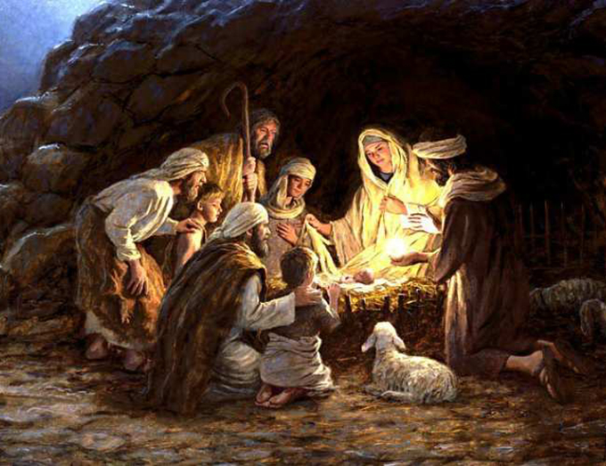

Merry Christmas and Happy New Year!!!
Please see the other side of this page for the 2nd semester schedule.
Three Parishes One Faith – Faith Formation Schedule
5K – 8th Grades at St. Ann
Monday Program January through Wednesday May 2026

Date | Class Time | Details
January 5th | 6:00 – 7:00 P.M.
January 12th | 6:00 – 7:00 P.M.
January 19th | 6:00 – 7:00 P.M.
January 26th | 6:00 – 7:00 P.M.
February 2nd | 6:00 – 7:00 P.M.
February 9th | 6:00 – 7:15 P.M. | Family Event  Parents of students in 5K – 6th grades should attend with their children for an Lenten project.  7th and 8th graders Service Project. We will all gather in the Church basement.
*February 16th | NO CLASS | February 18th ASH WEDNESDAY MASS  Students/families are encouraged to attend Mass.  PLEASE SEE BULLETIN for Mass times.
February 23rd | 6:00 – 7:00 P.M.
March 2nd | 6:00 – 7:00 P.M.
March 9th | 6:00 – 7:00 P.M.
March 16th | 6:00 – 7:00 P.M.
March 23rd | 6:00 – 7:00 P.M.
*March 30th | NO CLASS | HOLY WEEK - SEE BULLETIN FOR MASS TIMES.
April 6th | 6:00 – 7:00 P.M.
April 13th | 6:00 – 7:00 P.M.
April 20th | 6:00 – 7:00 P.M.
April 27th | 6:00 – 7:00 P.M.
*Wednesday May 6th | FF Closing Mass 6:00 P.M. | All students 5K – 10th and families.  At Holy Rosary

